Rules :
- Don’t use any SQL functions (Stored Procedure, views, pivot etc).
- Use connection string to connect with Database

Description
There is a database of product order requests to manufacture different products (will be referred as Finished Goods (FG) here after). To manufacture a FG, set of raw materials (RM) will be used. The way to manufacture a FG is already predefined.

Ex: Let us assume there is an order to prepare 100 Ltrs of Tea. Here we call Tea as Finished Good (FG). To prepare Tea, we need Milk, Sugar, Water etc.. we call these items as Raw Materials (RM). All these items Tea, Milk, Water, Sugar have unique Id’s we call it Material No. (also known as product code).

Table TBL_PRODUCT_HDR has order requests (like OrderNum P1, P2 etc).
A product that has to be manufactured has a product code. The product codes are in the field by name Material.

TBL_PRODUCT_HDR
OrderNum | OrderDate | Material No.
P1 | 20160130 | 1250559
P2 | 20160212 | 1271722
P3 | 20160226 | 2064610
P4 | 20160312 | 1592706

Table TBL_PRODUCT_DTL has raw material list that has to be added to manufacture a finished goods/FG. For example, to produce a product 1250559 against order P1, raw material 983979 of batch B1 and qty 10 KG has to be mixed along with material 883579 of batch B2 and qty 25 KG. The expiry date is the expiry date of the raw material batch. The expiry date is stored in YYYYMMDD format.

TBL_PRODUCT_DTL
OrderNum | Material No | Batch | ExpiryDate | Qty | UOM
P1 | 983979 | B1 | 20161201 | 10 | KG
P1 | 883579 | B2 | 20161115 | 25 | KG

Table TBL_MATERIALINFORMATION has material master data like material description and shelf life of a material. Type FG – Finished Goods; RM – Raw Material.

TBL_MATERIALINFORMATION
Material No | MaterialDesc | ShelfLife | Duration | Type
1250559 | TECHNOMELT DM ME22E* CTN20KG | 175 | DAY | FG
983979 | TECHNOMELT DM ME110E* 20KG DM | 115 | DAY | RM
1271722 | XUS 40782.00 Coalescing Agent | 140 | DAY | FG
883579 | AQUENCE LA 21008 B 1000KG | 210 | DAY | RM

Note: The expiry date of any material can be calculated based on material’s production date plus shelf life (Expiry date = Production date + Shelf Life).

Note : Problem 1 and Problem 2 are expected to be done in 1 solution only. Create separate pages for both the problems.

Problem 1 :
Create a page using ASP.NET for capturing the information of TBL_MATERIALINFORMATION and save the information in the database.
Material Information form should have below information

Prerequisite:
- Create this page using ASP.NET

Material - Max Size 18 - Mandatory
MaterialDesc - Max Size 200 - Optional
ShelfLife - Max size 5 - Mandatory - only numbers
Duration - Max Size 10 - Optional
Type - Dropdown - Mandatory - Selection Items - RM, FM

When Save button is clicked, save all the above information with proper validation in TBL_MATERIALINFORMATION table.

Problem 2 :

You need to create another page which lists all the orders in a dropdown. On selecting an order from a dropdown, the corresponding raw material list should display in the below table as shown below.

Prerequisite:
- This page should be created using HTML and JavaScript.
- Creating Rest API’s(to bind dropdown and to bind table) and calling them using Ajax is mandatory.
- Page will be considered Invalid if built using ASP.NET.

The dropdown content should be in the below format.
[Order Number] – [Material no] – [MaterialDesc ]
Or
[Order Number]
Example: P1 – 1250559 - TECHNOMELT DM ME22E* CTN20KG DM
Or P1
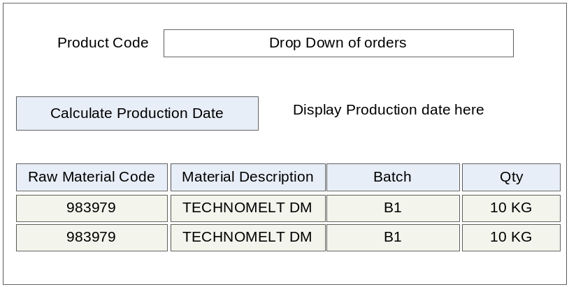

Next, on click of ‘Calculate Production Date’ button you need to calculate the production date of the finished goods that is selected from the dropdown. The logic to calculate production date is as follows.

  - If only one raw material then production date of that raw material becomes production date of the FG.
  - If multiple batches of same raw material then production date of earliest becomes production date of FG.
  - If multiple batches of different raw material then first expiry date of the raw material becomes expiry date of FG & production date of FG is back calculated based on shelf life period of FG.

